Creating a Staging table and export data from Ax to the Staging Table.
1. In MS-SQL Management Studio, we create a script to create the Staging Database plus a table in it. In Dynamics Ax we will create ascript that the contents of the CustGroup table will exported to this Staging table.
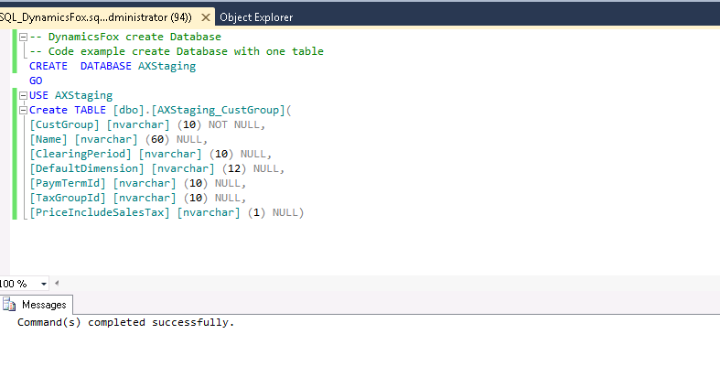

2. After excecute the script it looks like this.
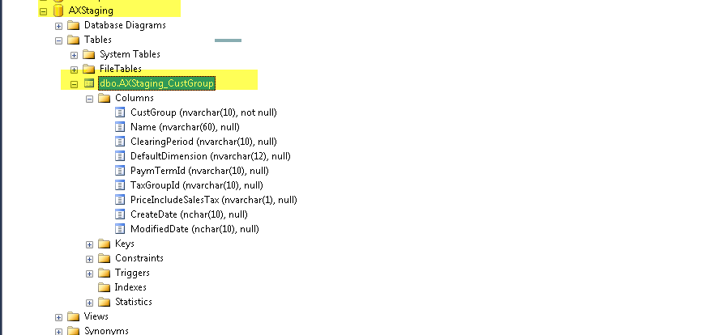
3. At the Staging database, set the propeer authorization level for the user or service account.
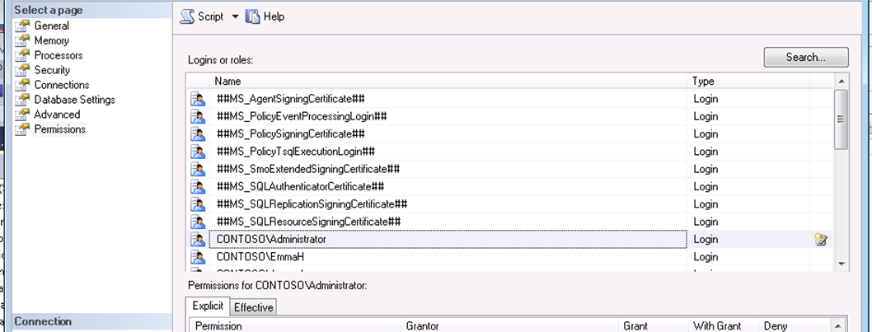

4. Now we create a class in Ax. This class will export the content of the CustGroup table into the staging table. The class should be run on the server level. It's recommendable to set 'RunOn' property to 'Server'.
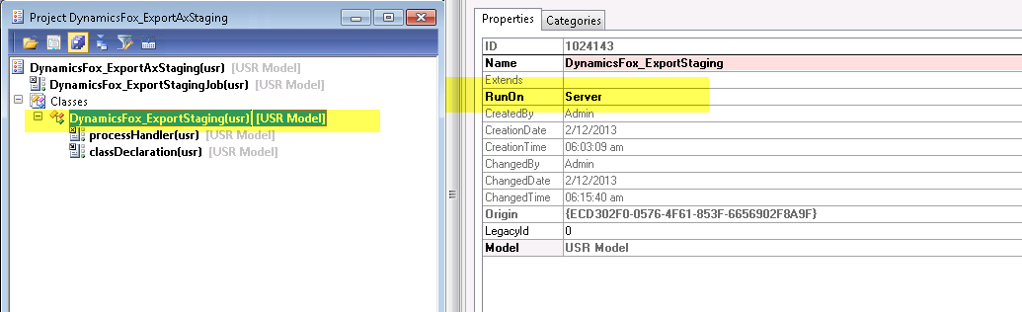
If the class is run on client level we will receive following error message.
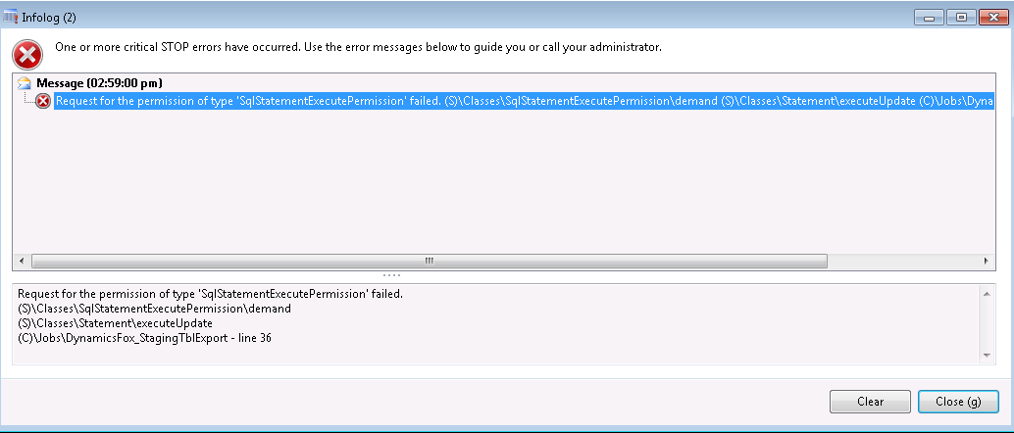
The logic in the class for exporting the CustGroup table to the staging table we can see in the below screendump.
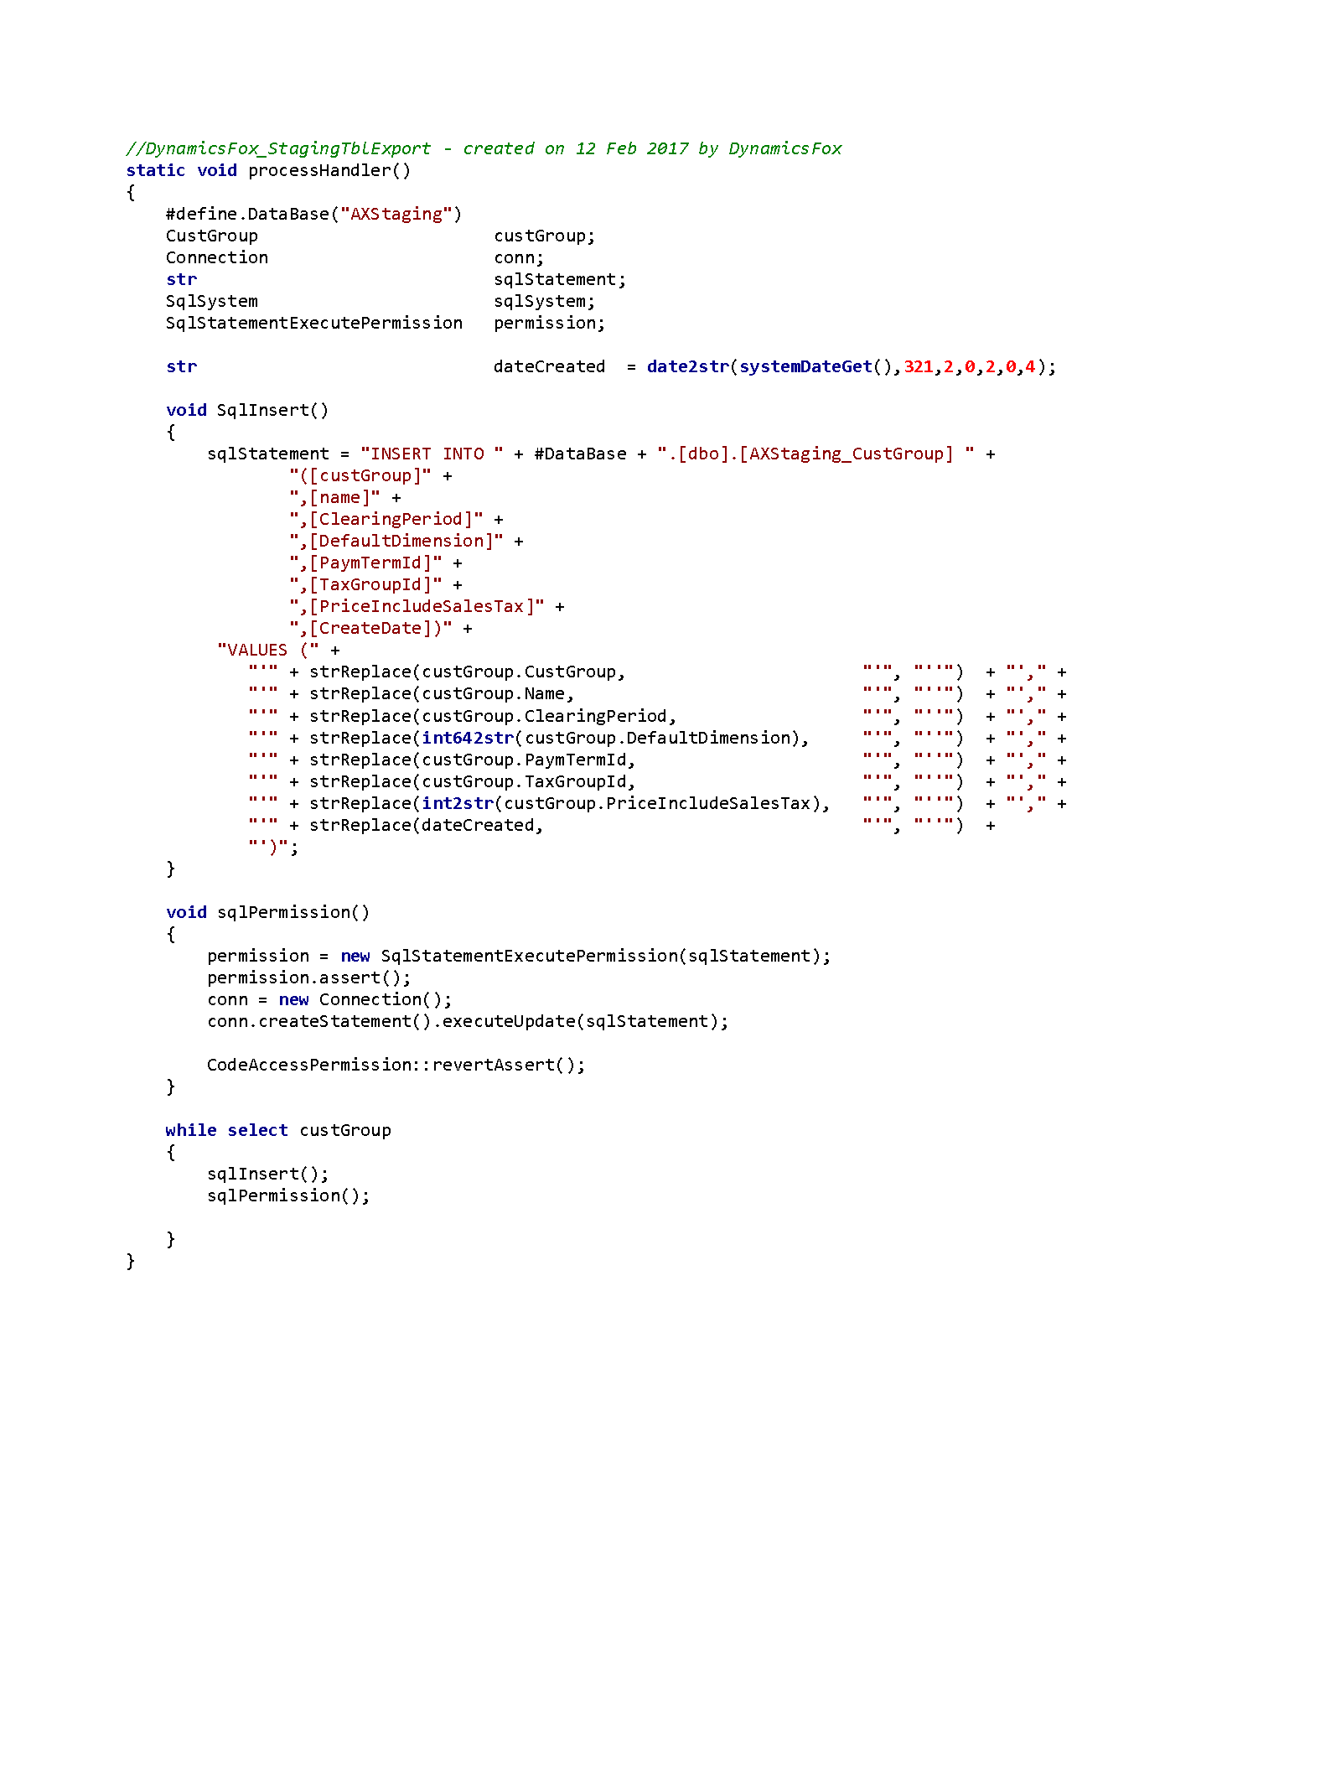

We can execute the class by a static call in a job:
